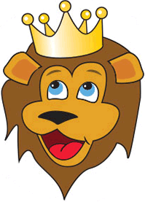
King of the Jungle Adventure

Parent and Leader Guidebook: page 41-49
Lion Adventure Book: page 8

Materials
- Copies of King of the Jungle handout, one per adult
- Copy of Den Meeting Plan, one for leader(s)
- Name tags and Sharpie
- Cub Scouts Poster Set with Scout Law, Scout Oath and Den Code of Conduct
(#621086 from Scout Shop)
- Blue tape or something to hang posters on wall

Optional
- Snack and water
- Activities for siblings (e.g., coloring books)

Gathering
- Leadership symbol to hide

Activity 1: Follow the Leader Game
- Ideas for follow the leader

Activity 2: Citizen Lion
- Copy of Parent and Leader Guidebook, page 44-47
- 2 bags or bowls, one marked “Yes” and one marked “No.”

Activity 3: Flag Mosaics
- Sample project completed as an example
- One piece of white construction paper, one per Scout
- Torn scraps of red and blue construction paper
- White paint (washable)
- Little paper plates to put small amounts of paint
- Cotton swabs or Q-tip
- Paper towels
Hint: have strips of red cut ahead of time. Have the blue field cut out ahead of time.

Wrap Up Game
- Colored pencils, crayons or markers
- Few extra copies of Lion Adventure Book page 8 (for those who forget book).

Supplemental: Book, optional
- Color copy of America, America, What Do You See? book to read
- Black and white copies of America, America, What Do You See? book for Scouts to take home.
Den Meeting Plan
King of the Jungle

Gathering
- I Spy – Leadership Version

Opening
- Good conduct candle
- Pledge, Scout Oath, Scout Law
- Give a big Lion Roar!

Talk Time
- Den business
- Sharing time

Activities
- Activity 1: Follow the leader
- Activity 2: Citizen Lion
- Activity 3: Flag Mosaics
  - How many stars are on the flag? 50
  - What do the stars stand for? 50 states of the US
  - How many stripes? 13
  - What do the stripes stand for? 13 original colonies
- Activity Wrap-up: Lion Adventure Book, page 8

Closing
- Pass folded flag. Lions identify one reason they love living in America
- Scout Law

Fun Flag Facts:
- Betsy Ross made the first flag
- 7 red strips and 6 white strips
- 13 Original Colonies: Connecticut, Delaware, Georgia, Maryland, Massachusetts, New Hampshire, New Jersey, New York, North Carolina, Pennsylvania, Rhode Island, South Carolina, Virginia
- Final star: Hawaii in 1960
- Colors: Red stands for courage, hardiness, and bloodshed. White stands for purity and vigilance. Blue stands for justice and perseverance.
King of the Jungle Adventure

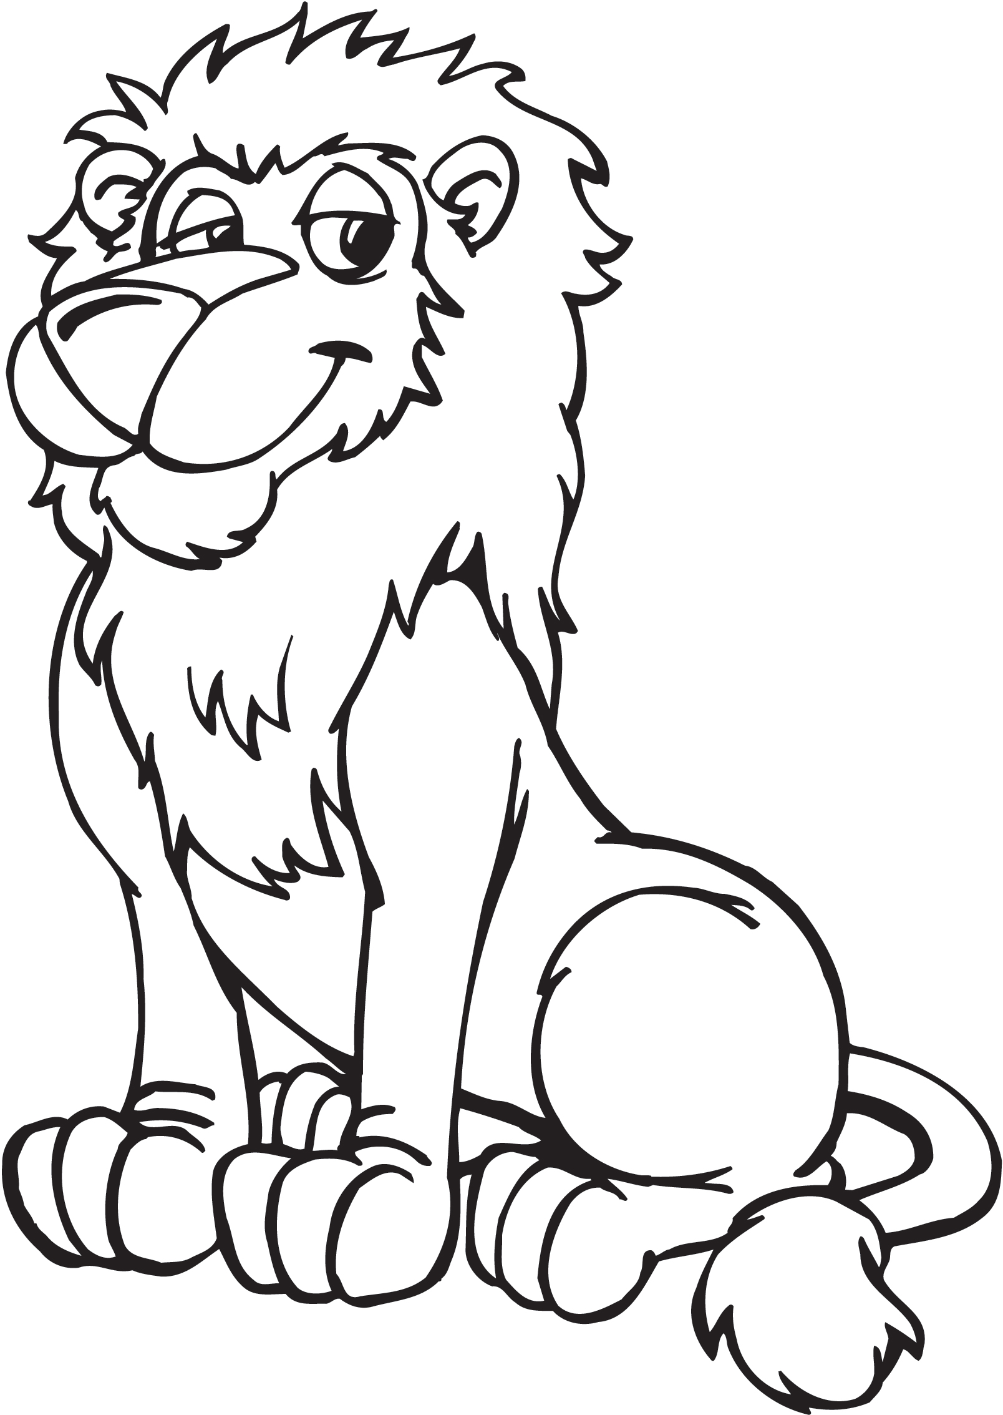
Scout Law
A Scout is trustworthy, loyal, helpful, friendly, courteous, kind, obedient, cheerful, thrifty, brave, clean, reverent.
Scout Oath
On my honor, I will do my best to do my duty to God and my country and to obey the Scout Law; to help other people at all times; to keep myself physically strong, mentally awake, and morally straight.

Upcoming Events

Dec 16 Wreaths Across America, optional
10:00 am at Houston Cemetery

Dec 20 Pack Meeting
(bring donation of first aid supplies)

Jan 10 Den Meeting
TBD Outing

Feb 7 Den Meeting
Feb 24 Pinewood Derby
Feb 28 Pack Meeting
Mar 7 Den Meeting

Pack 72
facebook.com/pack72tomball
pack72tomball.scoutlander.com
Orion District
www.orion.shac.org
facebook.com/orionbsa
Sam Houston Area Council
www.shac.org
facebook.com/shac.bsa

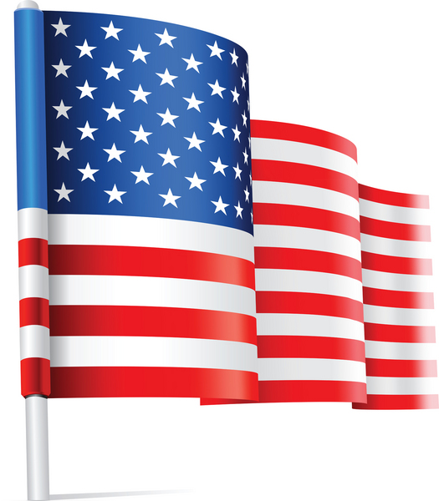

Flag, flag, what do you see?

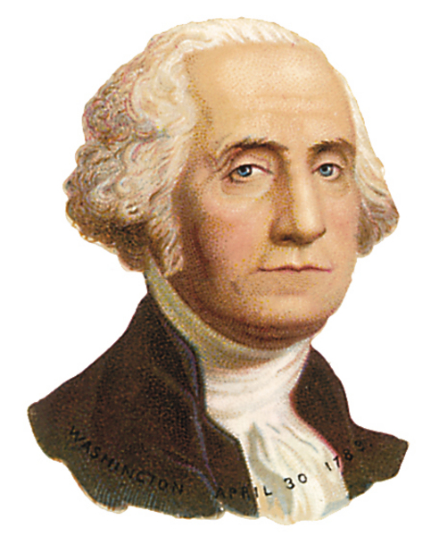

I see George Washington looking at me.
George Washington, George Washington
what do you see?
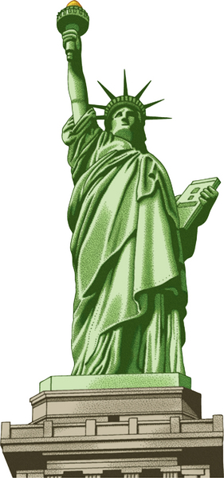

I see the Statue of Liberty looking at me.

Statue of Liberty, Statue of Liberty,
what do you see?

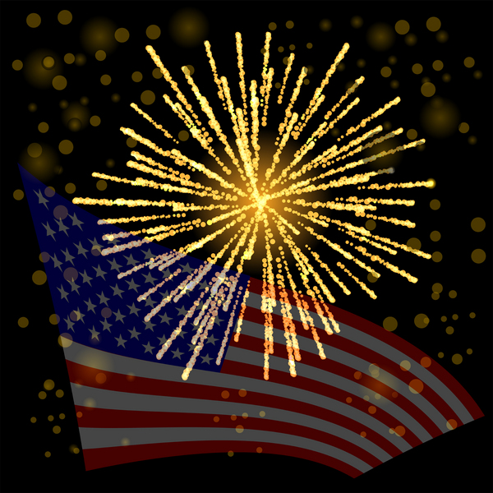

I see fireworks looking at me.

Fireworks, fireworks, what do you see?
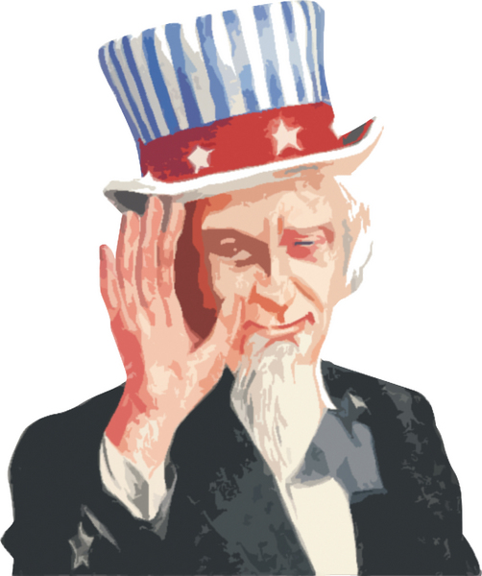

I see Uncle Sam looking at me.

Uncle Sam, Uncle Sam, what do you see?

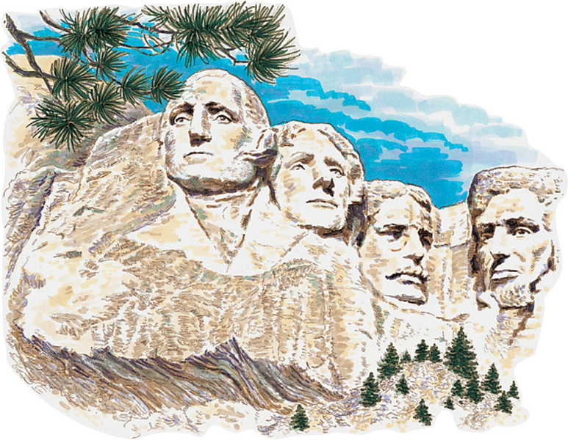

I see Mount Rushmore looking at me.

Mount Rushmore, Mount Rushmore,
what do you see?
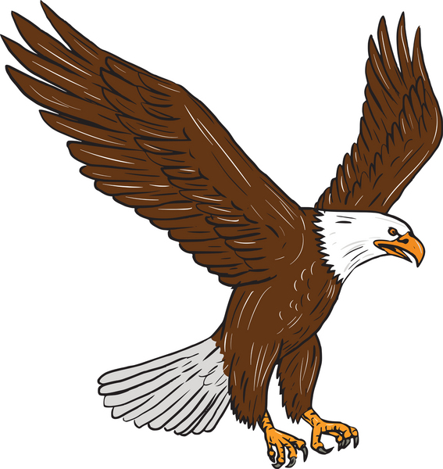

I see a bald eagle looking at me.

Eagle, eagle, what do you see?

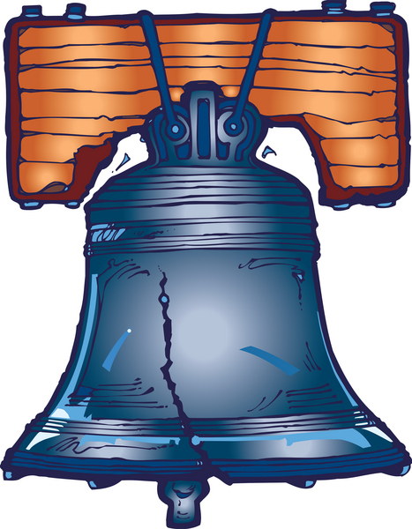

I see the Liberty Bell looking at me.

Liberty Bell, Liberty Bell, what do you see?

I see the White House looking at me.

White House, White House, what do you see?

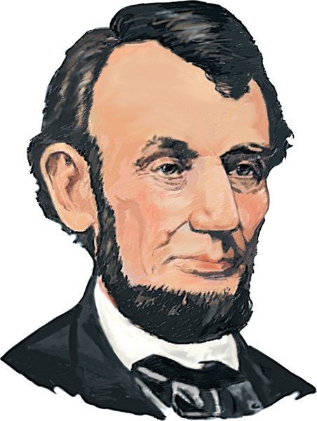

I see Abraham Lincoln looking at me.

Abraham Lincoln, Abraham Lincoln,
what do you see?
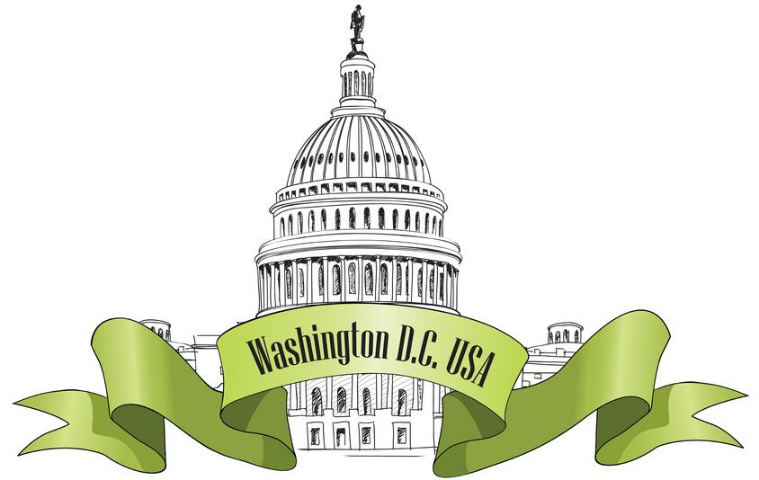

I see the capitol looking at me.

Capitol, capitol, what do you see?

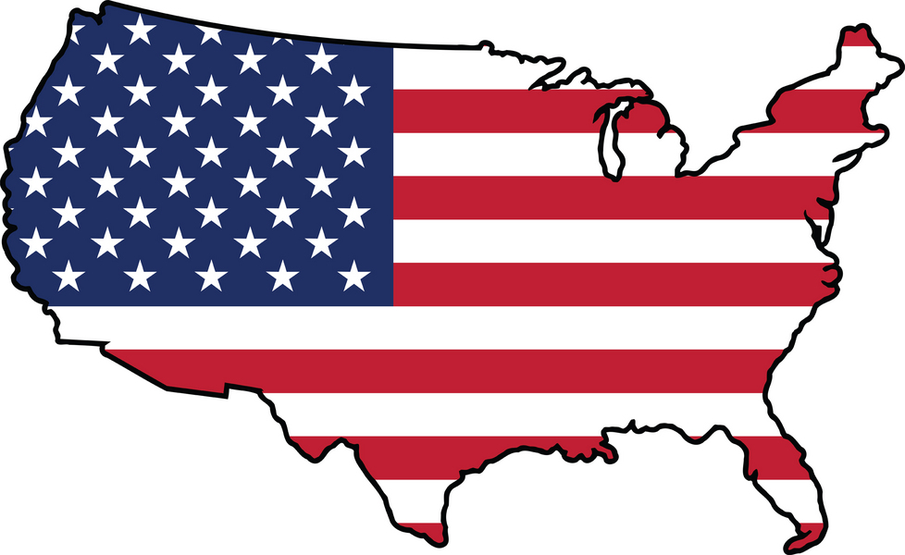
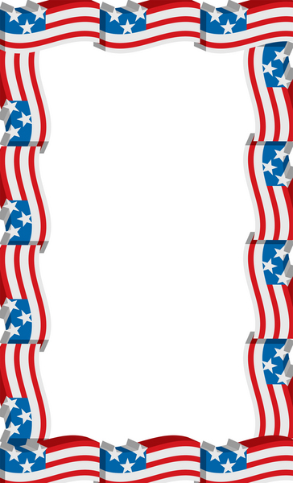
I see America looking at me.
The greatest country in the world
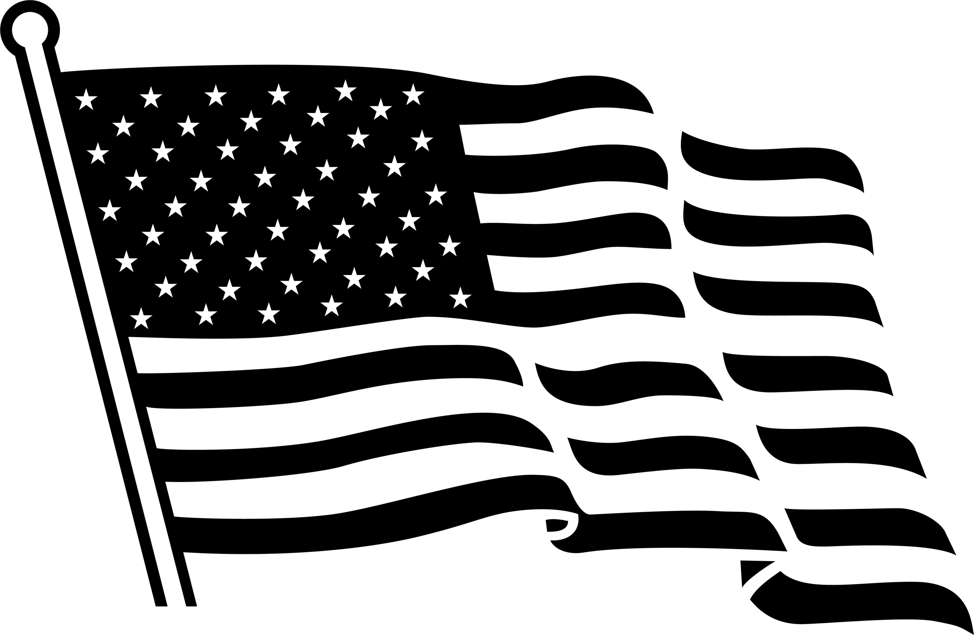
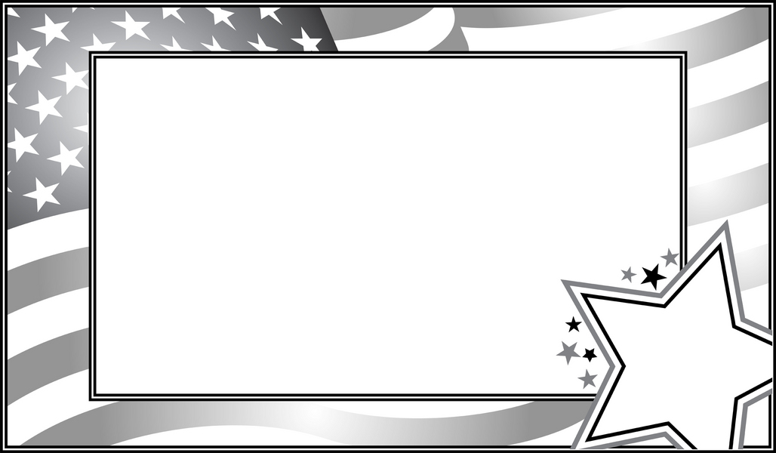
Flag, flag,
what do you see?

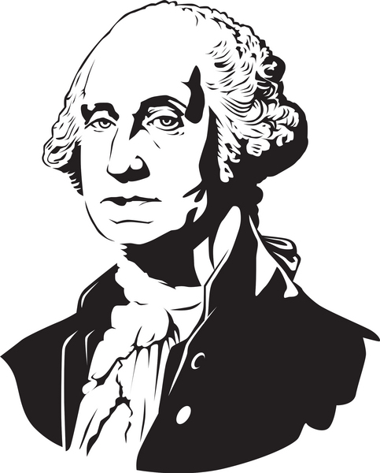

I see George Washington looking at me.
George Washington , George Washington
what do you see?
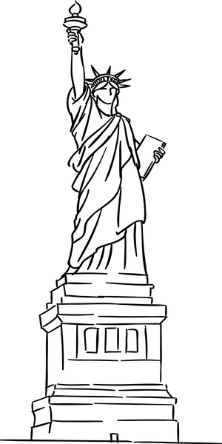

I see the Statue of Liberty looking at me.

Statue of Liberty, Statue of Liberty,
what do you see?

I see fireworks looking at me.

Fireworks, fireworks, what do you see?

I see Uncle Sam looking at me.

Uncle Sam, Uncle Sam, what do you see?

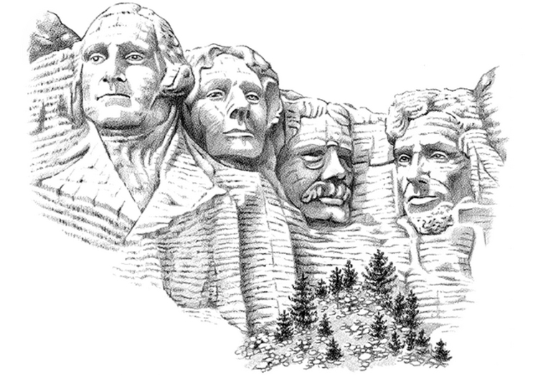

I see Mount Rushmore looking at me.

Mount Rushmore, Mount Rushmore,
what do you see?
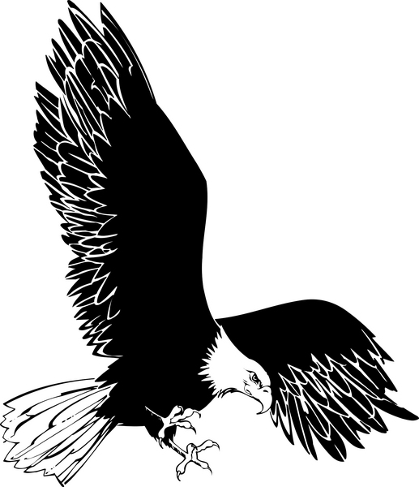

I see a bald eagle looking at me.

Eagle, eagle, what do you see?

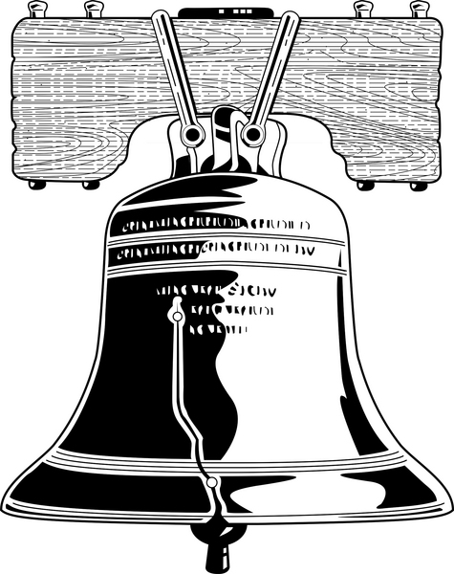

I see the Liberty Bell looking at me.

Liberty Bell, Liberty Bell, what do you see?

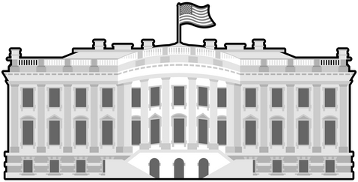

I see the White House looking at me.

White House, White House, what do you see?

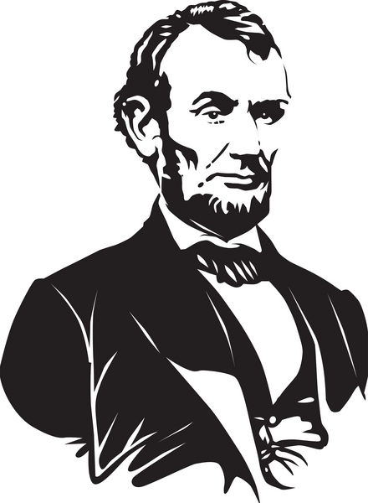

I see Abraham Lincoln looking at me.

Abraham Lincoln, Abraham Lincoln,
what do you see?
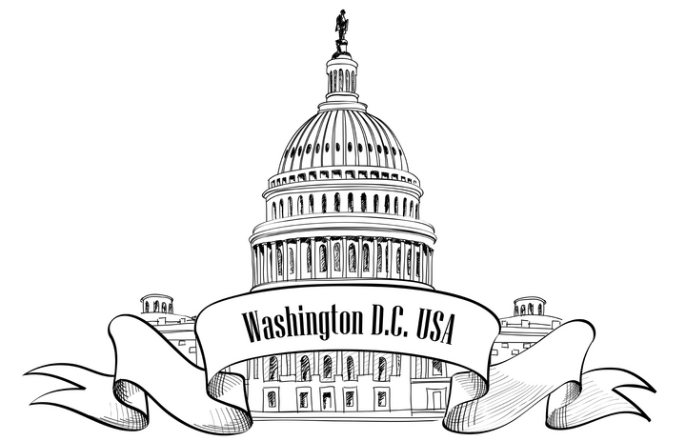

I see the capitol looking at me.

Capitol, capitol, what do you see?

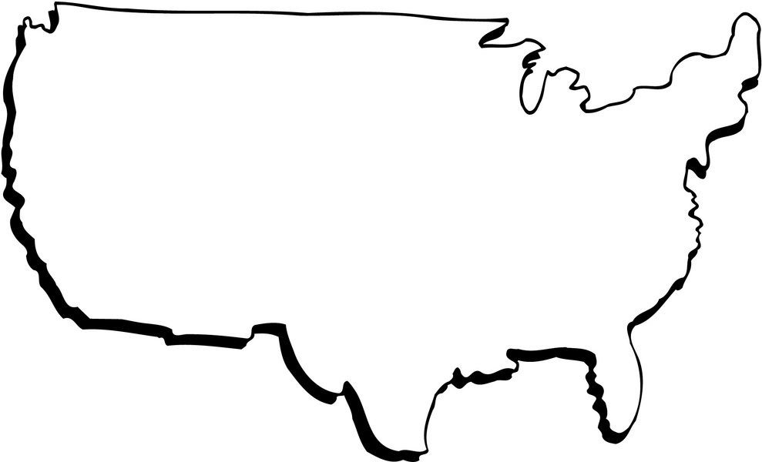
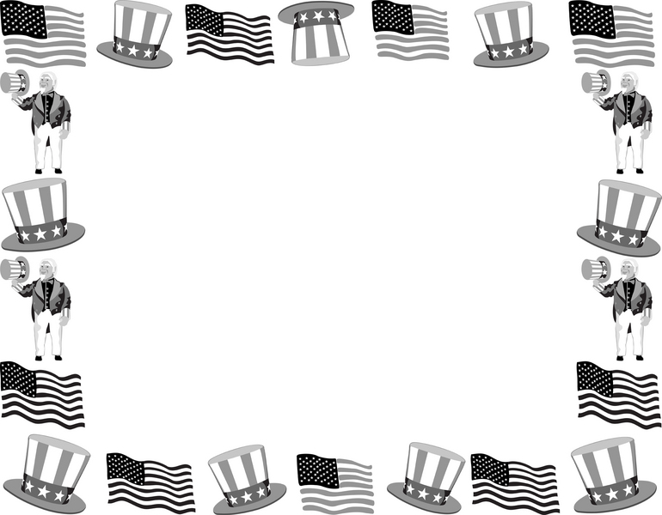
I see America looking at me.
The greatest country in the world

